# Evaluation

In this section, the results obtained from the game and saved in the database are extracted and evaluated. The plan seeks to determine whether the trolley dilemma would be successful or not in AV cars, it will also show the different responses made by participants which choose different routes to the same traffic accident. From these results a general idea could be drawn based on the majority of the decisions taken by the participants for the same scenario.

The following will be presented:

1. The percentage of the participants who took the Utilitarian approach (chose to save the most lives)
2. The percentage of the participants who choose to uphold the law
3. The most killed character/group
4. The percentage of the participants who valued human lives over those of animals
5. The percentage of the participants who chose whom to kill according to the age group of the character
6. Average time taken to decide

The above results will be divided according to demographic information such as gender, age or nationality as required, which was presented to the participants before the start of the game. The results will determine the preferred approach in such situations and thus, the preferred reasoning autonomous cars should adopt when faced with the Trolley Dilemma.

## Most Killed Characters

Surprisingly, the most killed character was the dog. The dog was presented in 849 scenarios and killed in 53.95% of them. When presented against any other character in the game (Figure 1), including the car passengers, the dog is nearly always chosen to die. The only exception is groups of old women, where in this scenario, dogs were killed 15.63% of the time and old women were killed in 37.5% of the responses. This clearly portrays the participants’ belief that preserving human life is much more important than protecting animals, and undoubtedly implies that, preferably, autonomous vehicles should do the same.

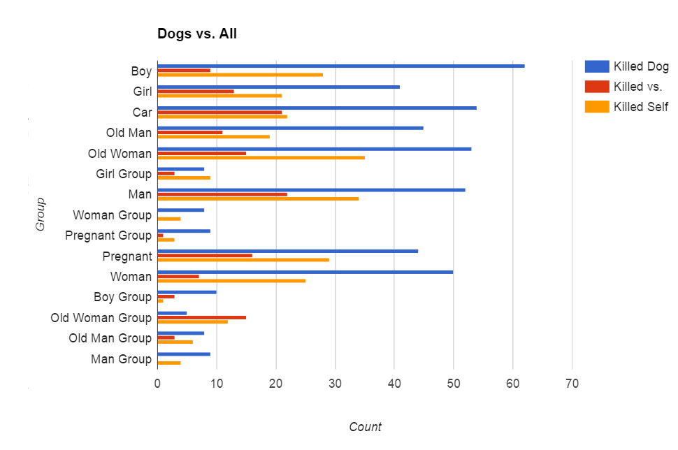

Figure 4 – Comparison of the choice to kill the dog/s against each of the other characters

Table 1 shows more valuable information on which characters participants decided to save. Children and adults were killed only 15.04% and 18.28% of the time respectively, whereas old people were killed 35.46% of the time. Gender also plays a small part in the choices made, as males were killed in 24.11% of the scenarios presented, compared to females’ 21.12%. It is clearly noticeable that the boy group was given most importance as they were saved 91.49% of the time.

| Choice | Count | Kill Count | % |
| --- | --- | --- | --- |
| Boy | 788 | 121 | 15.36% |
| Boy Group | 141 | 12 | 8.51% |
| Car | 815 | 366 | 44.91% |
| Dog | 849 | 458 | 53.95% |
| Dog Group | 106 | 43 | 40.57% |
| Girl | 730 | 120 | 16.44% |
| Girl Group | 129 | 16 | 12.40% |
| Man | 785 | 194 | 24.71% |
| Man Group | 136 | 21 | 15.44% |
| Old Man | 769 | 281 | 36.54% |
| Old Man Group | 143 | 37 | 25.87% |
| Old Woman | 825 | 322 | 39.03% |
| Old Woman Group | 141 | 26 | 18.44% |
| Pregnant | 779 | 97 | 12.45% |
| Pregnant Group | 133 | 12 | 9.02% |
| Woman | 774 | 163 | 21.06% |
| Woman Group | 134 | 14 | 10.45% |
| Self | 4083 | 1779 | 43.57% |

Table – Number of times a character was presented in a scenario, and the number of times it was killed

## Single vs. Groups

From the 933 scenarios in which participants were presented with a group of characters against another single character, only 159 (17.04%) chose to kill groups. The rest either chose to kill themselves as the car passenger (46.84%), or to kill another pedestrian (36.12%) (Figure 2).

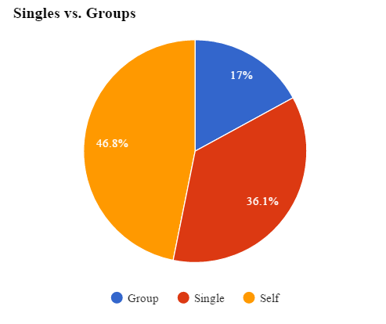

Figure 5 – 82.9% of responses prefer killing a single person (car passenger or pedestrian) rather than groups of people

It is clear that killing the least number of lives possible is of utmost importance to the participants, with 82.9% of responses indicated that it would be better if one person is killed (either car passenger or any other pedestrian) rather than a group of people. Thus, it can be implied that participants might prefer Utilitarian autonomous vehicles which choose to save as many lives as possible.

## Upholding the law

In a number of scenarios, participants also had to take into consideration basic road laws and whether characters were breaking or abiding by these laws. Considering only the responses received from these scenarios, which amounted to 1221 (22.9%) responses, not much importance was given to whether the pedestrians were obeying the laws or not. This may be the result of lack of observation from the participants. However, there still was a slight difference, with 5.2% more people choosing to save characters who were abiding the law (waiting on a red light, crossing on a green light, etc.). A similar result can be retrieved when considering solely Maltese participants – in 53.44% of the responses, law abiding characters were saved.

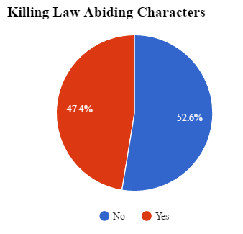

Figure 6 – In 52.6% of the cases, law abiding characters were saved, while 47.4% were killed

Following these results, it is clear that some participants believe that persons who abide the law should be prioritised and protected. It can be implied that participants would also want autonomous vehicles to do the same, even at the expense of their own lives.

## Killing Self vs. Killing Others

From 4083 responses, 43.57% of participants decided to kill the passenger in the self-driving car, which represents the participants themselves. Maltese participants opted to kill themselves in 42.31% of the case. Noteworthy is the comparison between genders – the majority of male participants, with 52.37%, chose to kill themselves, against the 47.34% of female participants and the 43.14% of participants who identify themselves as other genders.

When evaluating which characters participants decided to sacrifice themselves for (Figure 7), it emerges that participants would save all human characters rather than save themselves. However, when presented with dogs, only 36.9% of participants decided to kill themselves. Furthermore, 55.9% of participants decided that it is better to hit a car (killing its passenger), rather than kill themselves. When presented with a group of characters, an overwhelming majority of 74.22% decided to save the group.

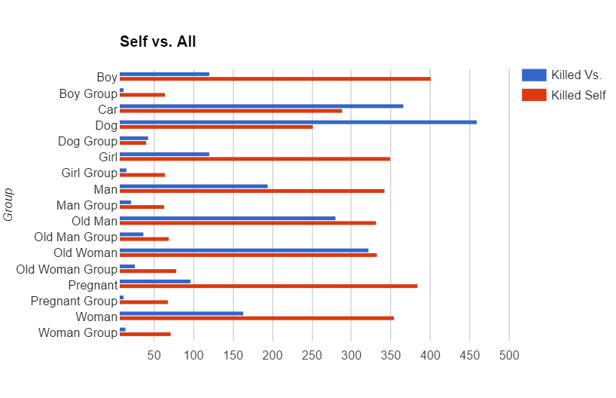

Figure 7 – Comparison of the choice to kill oneself against each of the other characters

## Ages

When comparing the ages of the characters – children, adults, and elderly people – a lot of information can be retrieved. Participants tended to prefer saving young children (Figures 8 and 9), where 17.6% were killed when presented against adults, and only 9.8% were killed against elderly people. Additionally, the trend of saving the young continues at higher ages – only 15.8% of participants chose to kill an adult when presented against elderly people (Figure 10).

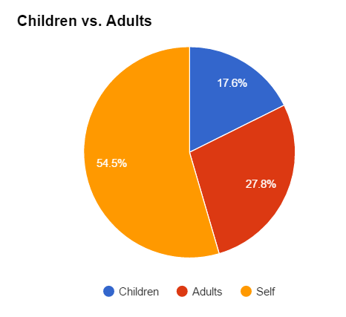

Figure 8 – Comparing children and adult kill rates

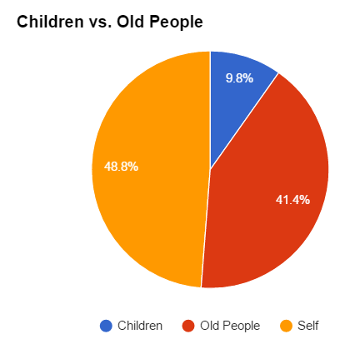

Figure 9 – Comparing children and elderly people kill rates

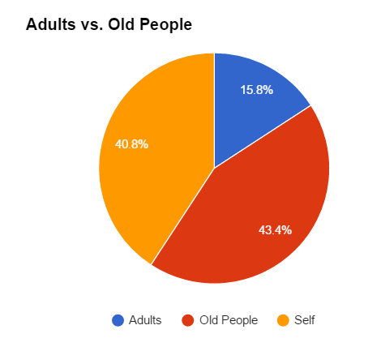

Figure 10 – Comparing adult and elderly people kill rates

It is clear that participants prefer to kill older people, while prioritizing the protection of young children. Presumably, these participants would want autonomous vehicles to somehow determine the age of the people in a scene and save the youngest people when such a scenario occurs.

## Time taken to make Decision

The average time taken to make a decision is approximately 1.36s, where participants were given 3s. This figure also includes the 401 responses in which no action was taken (which amount to 9.8% of the responses), for which time taken was recorded to be 3s. Considering only responses in which action was taken, the average time taken drops to approximately 1.18s. 15.7% of the responses arrived in the last available second (Fig. 9). An overwhelming majority (74.5%) of participants assessed the scenario presented and took action in less than 2 seconds.

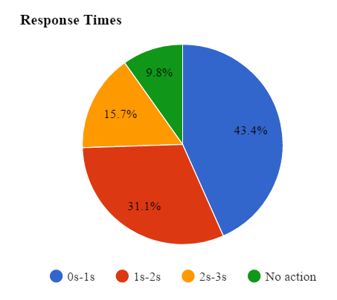

Figure 9 – Response Times

The results show that participants were given enough time to make their decision; with the majority taking less than one second to make their choice, the latter time could be due to the reaction time of a human being rather than the time period for a decision to be taken. However, this may also result in some inaccurate results due to a lack of observation.

These results help in determining whether autonomous vehicles should ask the driver to take a decision when the scenarios presented by simulation occur in real-life. If the self-driving car were to offer a time margin during which a decision is made by the driver, this margin must be at least two seconds, considering that the average time taken was 1.18s when action was taken, and that nearly 75% of participants responded in the first two seconds.

Findings from this experiment also showed that people would prefer saving a child or a young adult rather than an older person, a reason behind this dilemma might be that the younger generation has more to give in life. Moreover although animals are becoming important as well for humans, a distinction could still be made when a choice on which specie to kill is given to the driver. Since the dog which represents different animals was mostly killed to save a human life, this portrays the fact that for most people humans are more important than animals and should therefore be saved.

On the contrary to the above it could also be the case that some of the participants although they like animals they do not like dogs and for this reason they choose to kill it, in such cases the findings might not be accurate enough.

In the case of people upholding the law, results showed that there was not much difference between those people who were obeying the law and those who were not and still got killed. In real life people try to avoid any casualties and at that moment it is slightly hard to observe everything and kill the ones not obeying the law in those couple of milliseconds or seconds where the driver must make a crucial decision. Although this was a simulation and not in real life, we think that in real life this gap between people upholding the law and those who are not but still being killed would be negligible or at least much smaller than the one obtained as in some real life accidents there is not enough time to calculate and reason everything.

Additionally although not much reasoning can be done at that time there would still be room for some calculations, for example if there is a person and a car the probability of a slow moving vehicle to not get killed is higher than a person walking. In most cases this logic was made. Some other logic which was also present was to either kill a person and save a group of people or vice versa. We did not delve into the detail of a relative member being one of the choices so these 2 possible decisions represent people who the driver does not know. If possible the group is always saved and in this case people chose to take the utilitarian choice. At this point in time participant could have also thought that although either of the decision taken has a consequence the more people killed the worse the consequence will be. This could also be the logic being those people who chose to kill themselves, in some countries after an accident happens there is this mentality that the driver who might have followed the law unlike the pedestrians or other vehicles who were involved in the accident be accused and blamed for the accident.

Finally, according to “The Human Benchmark: Reaction Time Statistics” [1], the average reaction time of a human being is: 215 ms, this shows that those participants having the average time for a decision to be taken of 1.18 seconds took less than 1 second to decide. Additionally it also states that as time goes by the reaction time is also increasing which implies that there could be the case where some participants took even less time to decide when the reaction time was deducted.

[1] http://www.humanbenchmark.com/tests/reactiontime